SOP Template
1. CHEMICAL NAME(S)  and associated  PHYSICAL and  HEALTH  HAZARDS | [Chemical Name] – CAS# [Insert CAS#] also known as [Synonyms].  Hazards  - [Insert chemical hazard statements/descriptions and chemical information]  Pictograms [Consult SDS and Label – Remove those that do not apply]  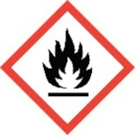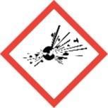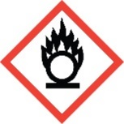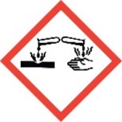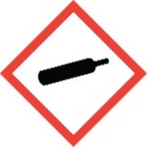  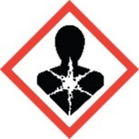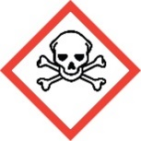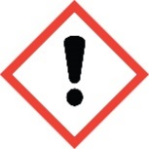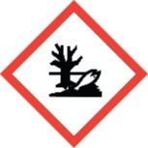  Signal Word: DANGER or WARNING [Use only one – Consult SDS and Label]  Exposure Limits: [Consult WAC 296-841 Table 3, SDS, NIOSH pocket guide, etc.]  [Insert: TWA, STEL, PEL, etc.]  Toxicological Data: [Consult SDS]  [Insert: LD50-Oral, LD50-Dermal, LC50-Inhalation, etc.]  *Always refer to the Safety Data Sheet for the most detailed information*
2. PROTECTIVE  EQUIPMENT | Wear [type of eye protection], [type of glove] gloves, and a fully buttoned lab coat. Wash hands after removing gloves. Work within a certified laboratory chemical fume hood.  [Insert/Modify any specific or additional PPE required.]  [Insert/Modify any specific or additional engineering controls required.]
3. WASTE DISPOSAL  PROCEDURES | Waste [Chemical Name] must be collected in a sealable, compatible waste container. Placing waste container in secondary containment is recommended. The container should be stored away from incompatible materials such as [Insert chemicals here]. [Insert/Modify any specific or additional waste disposal procedures required.]  A completed Dangerous Waste label should be attached when waste is first added to the container. When container is full or no longer being used, complete a Chemical Collection Request Form, and deliver to the Waste Accumulation Area Operator at [Building, Room, Phone Number].
4. DECONTAMINATION  PROCEDURES | Upon Accidental Exposure:  In case of eye contact, flush eyes with copious amounts of water at an emergency eyewash station for at least 15 minutes and seek medical attention.  In case of skin contact, flush skin with copious amounts of water for 15 minutes and seek medical attention. For exposure over a large portion of the body, remove clothing and shoes and rinse thoroughly in an emergency shower for at least 15 minutes. Seek medical attention.  In case of inhalation, move person to fresh air and immediately seek medical attention.  In case of ingestion, immediately seek medical attention and follow instructions on SDS. Do not induce vomiting.  Upon Accidental Release:  Large Spill: If a large amount of [Chemical Name] is spilled outside the fume hood, immediately evacuate, secure area, and call 911 to contact EH&S.  Small Spill: If a small amount of [Chemical Name] is spilled (it can be cleaned up in 10 minutes) and you have been appropriately trained to clean it up, you may do so. Trained personnel should wear at the minimum [Insert glove type], chemical safety goggles, and a fully buttoned lab coat.  If it is necessary to use a respirator and personnel are not cleared to wear a respirator and not trained to appropriately clean up the spill, the employee should immediately evacuate, secure the area, and call 911 to contact EH&S.  Absorb with an inert dry material, or if the released substance is a solid, use appropriate tools to collect it, and place in an appropriate waste disposal container (resealable bag, etc.) and dispose of as hazardous waste (see above WASTE DISPOSAL PROCEDURES).  As with all accidents, report any exposure as soon as possible to your Principal Investigator or Supervisor. Additional health and safety information on [Chemical Name] can be obtained by referring to the SDS or by calling the EH&S Office (335-3041).
5. SPECIAL STORAGE AND HANDLING PROCEDURES | Keep container tightly closed until ready for use. Store in a secure, well-ventilated, cool, dry place away from sparks, heat, sunlight, or other sources of ignition. Store segregated from incompatible chemicals (below). Use secondary containment when possible. [Insert any additional storage or handling requirements].  Keep this substance away from incompatible chemicals such as [Insert Incompatible Chemicals].

